Ingomar Franklin Park Little League Code of Conduct, Responsibilities, and Expectations
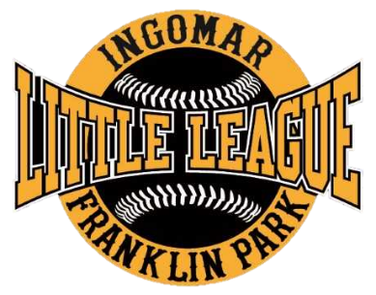

Managers and Coaches Code of Conduct
- Managers and Coaches will set a good example of moral and ethical behavior and will not demean, intimidate, verbally abuse or threaten any other player, parent, guardian, coach, umpire or league official.
- Managers and Coaches will coach in a positive manner displaying good sportsmanship, fair play, and appropriate behavior and will not place winning above the physical and emotional well-being of the players.
- Manager and Coaches will respect the judgment of the umpires and will not argue or protest excessively ball/strike, fair/foul, or out/safe calls.
- Managers and Coaches will handle any disputes off the field and will not openly discuss problems or complaints in front of players.
- Managers and Coaches will exhibit an attitude of teamwork and respect decisions made by league officials along with abiding by the rules and regulations of Ingomar Franklin Park Little League. The hierarchy of the IFPLL authority shall be:
Executive Board > IFPLL President > IFPLL Vice President > League (Baseball/Softball) Vice President > Commissioner > Manager > Assistant Coach
- No tobacco products of any kind, alcohol, or illicit drugs are permitted in the dugout or on the field during practices or games.

Consequences
Failure to abide by the Coaches Code of Conduct may result in one or more of the following disciplinary actions.
- A written warning from the League Vice President copied to the Board of Directors.
- A one or more game(s) suspension.
- A season suspension.
- A permanent suspension from Ingomar Franklin Park Little League.

Parents and Spectators Expectations
- Remember that the players are children and are playing for their own enjoyment, not anyone else’s.
- Respect decisions made by umpires, league officials, managers and coaches.
- Praise the children for competing fairly and trying hard.
- Refrain from shouting instructions or criticism to players, coaches or umpire
Managers Responsibilities
- Communicating with team through the IFPLL website and apps thus assuring accurate reflection of all scheduled games and practices. If a manager reschedules or cancels a game or a practice, they must reschedule or cancel it on the website/app.
- Cancelling a game is at the discretion of the home team manager. The home team manager will determine whether a field is playable without excessive use of field dry or otherwise damaging the field.
  - In the event that a home team manger cancels a game, they must communicate that cancellation to the appropriate snack shack coordinator.
- Reading and following the rules of manager’s league.
- Performing proper field maintenance and preparation.
- Storing all field equipment.
- Restocking field supplies from storage shed. If something is out of stock in storage shed or if field equipment is missing, the manager needs to inform the league commissioner

Commissioner Responsibilities
- Solicit coaches and recommend to the League Vice President for approval by the Board of Directors.
- Create teams.
- For younger age groups: allocate players to ensure teams are competitively balanced utilizing the input of coaches and considering parent requests.
- For older age groups: implement a draft system utilizing the input of coaches.
- Explain the rules of the League to the coaches and make sure they are followed by all coaches.
- Ensure that all coaches know their responsibilities of field maintenance before and after games.
- Attend IFPLL Board meetings to report on your league.

